2021-2022 Google Classroom Codes

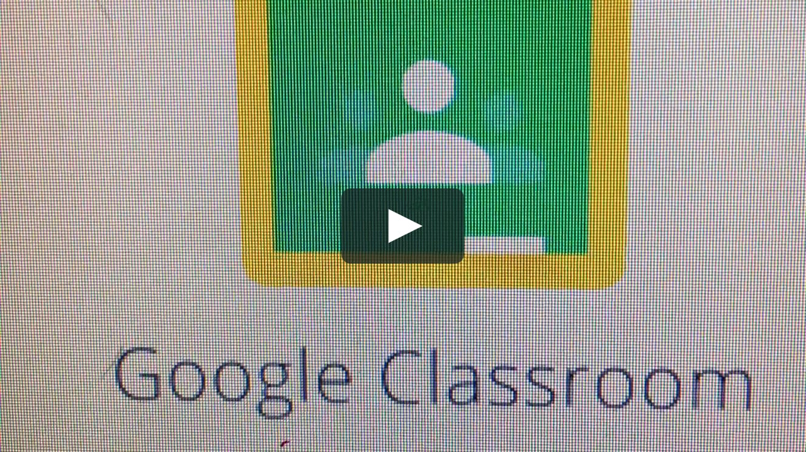

| Class Section | Period | Google Classroom Code |
| --- | --- | --- |
| Spanish 3 Honors | Period 1 | **3hd33uv** |
| Spanish 4 Honors | Period 2 | **6wybriq** |
| Spanish 3 Honors | Period 4 | **3hi4d6k** |
| Spanish 3 Honors | Period 5 | **u4qjeva** |
| Spanish 2 Honors | Period 6 | **2vplzmz** |