**Syllabus:** **ESL II, Period 5** **Teacher: Ms. Moore cmoore@winthrop.k12.ma.us**

**Google Class Code: v7bjx42**

**Materials Needed:**

***Folder/ Notebook, Blue / Black and Red Pens, Pencils & Eraser, and Highlighters***

**Couse Description and Expectations**

ESL II is a year-long course. ESL II builds on your English language skills: further developing your use and knowledge of grammar, sentence patterns, academic vocabulary, as well as your reading comprehension. Research projects, oral conversational practice, and presentations are included in this level. This class is designed to help you improve your ability to read and write the English language. Your goal is to refine your skills in reading comprehension and composition, as well as, your control of grammar, spelling, and language mechanics. You will also practice different learning strategies, and further develop your critical thinking skills.

**Standards:** *We have five* ***WIDA*** *standards and the four domains of speaking, listening, reading, and writing are embedded in each of these. These standards as well as the Massachusetts State Curriculum Frameworks drive the context of our course work throughout the year.*

Standard 1: Social & Instructional Language

Standard 2: The language of Language Arts

Standard 3: The language of Mathematics

Standard 4: The language of Science

Standard 5: The language of Social Studies.

**Student Performance Goals – Based on the Four Domains**

Students will learn:

**Speaking**

* Participate in classroom discussions and give class presentations on diverse subjects and

themes.

**Listening**

* Listen, take notes, and comprehend a variety of academic lectures and media presentations.

**Reading**

* Acquire academic vocabulary needed to obtain and process information for content-area subjects.
* Recognize and appreciate various forms of literature, with the ability to reflect on themes.

**Writing**

* Produce written work according to styles and conventions required for academic purposes.
* Develop skills for writing paragraphs and essays, including practice in all steps of the writing

process.

* Learn to incorporate increasingly sophisticated grammatical structures into their writing.

**Policies for Success: Attendance, Deadlines, Work Ethic, etc.**

* For both teacher and students to be successful, it is necessary to have a calm, respectful, and productive classroom.
* It is important that you attend class, actively participate in classroom discussions, and complete all reading and writing assignments on time with a critical eye for *quality*.
* It is important to be on time, prepared, as well as organized.
* Maintaining tolerance towards different backgrounds or opinions is imperative.
* Doing your best, being positive and respectful to yourself and others will help you to succeed.
* Taking responsibility for your learning and performance.
* Don’t shortchange yourself by wasting your time, wasting the time of others, making excuses, or cheating.
* Most importantly, ask for help when you need it.

**Assessment/ Grading/ Evaluation Practices**

* Your grades will be based on the classroom assignments, tests, homework and active class participation.
* Work missed because of an absence must be made up as soon as possible. If you need to make up a test, a quiz, or a class activity, see me as soon as you return to set up a time to make it up.
* Each assignment, quiz, class activity, or exam has a set number of points. All points are weighted equally.
* Late Assignments – are NOT acceptable. Your work needs to be turned in on time.
* All late assignments will have 20% of full credit deducted each day they are late.
* You will have the opportunity for extra credit periodically. Please take advantage of these opportunities!

# Exams, Quizzes, Assignments, Homework

At various times throughout the course, quizzes may be given on vocabulary terms, grammar, and reading comprehension. At the end of the first semester there will be a midterm exam and at the end of the second semester there will be a comprehensive final exam.

These quizzes/ tests can include any combination of questions, including essay questions. There are also W.I.D.A. level appropriate informational reading assignments as well as abridged literary selections, short stories, poems etc. Research projects are also assigned in Google Slide Show. All quizzes and projects have a percentage of 0 – 100%, and carry the same weight as all other grades. Exams are graded in accordance with WHS exam policies.

PLAGIARISM

Plagiarism is the practice of taking someone else's work whether written, a work of art, music, or ideas and passing them off as one's own. The WHS policy regarding this can be found on page 81 of the *Student Handbook,* and states:

“. . . Any student who cheats/plagiarizes on an examination, or any other assignment, shall receive a zero, and may not make-up such work. . . .”

Furthermore, the instructor, will then notify the parent/guardian, and will speak to the student privately about the issue.

THE VISION of the GRADUATE

Winthrop High School strives to ensure its graduates are able to become productive citizens of their town, their state, and their nation. To do this, the school in 2011 embraced the following learning objectives, on which students are evaluated quarterly. Taken together, they express a community vision for what we want our graduates to be, know, and do.

 WHS Students will become…

***Critical Thinkers***

·      They will use, apply, and evaluate multiple problem-solving strategies in a variety of

             disciplines.

·      They will be able to select, organize, and evaluate new ideas.

·      They will demonstrate the ability to actively and critically read.

·      They will develop the skills and acquire the knowledge necessary to prepare them for college and

career success

·      They will be able to set priorities, and manage their time and tasks.

***Effective Communicators***

·      They will communicate ideas and information with clarity and with an understanding

      of their audience.

·      They will integrate and use a variety of communication forms.

·      They will listen effectively and respond appropriately to spoken communication.

·      They will master standard English-language conventions.

***Conscientious Citizens***

·      They will be aware of, and follow, their community’s rules and laws

·      They will respect themselves and the community at large.

·      They will be aware of and respect social and cultural diversity.

·      They will understand, promote, and show the importance of hard work to achieve

      success.

·      They will own their mistakes, and will learn from them.

***Creative Achievers***

·      They will show curiosity and enthusiasm in everything they do.

·      They will work and think originally.

·      They will appreciate the arts in their many forms.

·      They will select, organize, and develop innovative ideas.

·      They will build off the ideas of others.

The *NEW* Cell Phone Use Policy, *Student Handbook,* pg. 79:

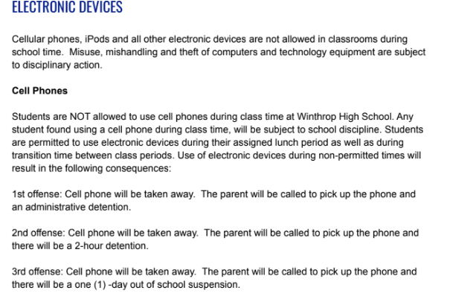

Finally, **WELCOME** to the ESL II Class! I am looking forward to working with those of you I already know, and getting to know those I do not yet know. I am here to help you do the best that you possibly can in this course. Do not hesitate to ask questions, and take pride in all that you do in class.



Note to the reader: This syllabus is posted in English and is available upon request in the student’s primary language.