NAME:

The Great Depression. 40 points.

**Multiple Choice**: pick the most appropriate option. One point each.

1. In what way did the New York Stock Exchange (NYSE) contribute to the Great Depression?
   1. It led directly to the German reichsmark crisis of 1923.
   2. Margin buying led to vastly overestimated wealth for investors.
   3. People with wealth in real estate, gold, or buildings lost all their money in the stock market.
   4. The NYSE did not contribute to the Great Depression.
2. What was the most significant problem with the US banking system in the years before the Great Depression?
   1. Its money was held in silver, rather than gold.
   2. Banks invested their holdings in the stock market.
   3. The banking system was controlled by the federal government.
   4. None of the money held by the banks was insured against loss.
3. The “Dust Bowl” migration led to massive emigration between what two parts of the USA?
   1. The Midwest to the West Coast.
   2. The West Coast and the Midwest.
   3. The East Coast and the West Coast.
   4. The South and the West Coast.
4. Like the US dollar after Roosevelt left the gold standard, and like the Russian rouble this past week, which of the following things caused the German reichsmark to lose nearly all of its value in 1923?
   1. Margin buying.
   2. Yellow journalism.
   3. Deflation.
   4. Inflation.
5. Roosevelt used which of the following events to connect with the American people during his early presidencies?
   1. Roles in popular movies.
   2. Air tours.
   3. Fireside chats.
   4. Television appearances.

**Matching I:** the Great Depression. One point each. You won’t use each term, and you won’t use any of them twice.

1. Recession.
2. The New Deal.
3. The gold standard.
4. NFL football.
5. Horse racing.
6. Depression.
7. Hoover Dam.

______ 6. This massive public works project provided electricity for southern California.

______ 7. This is a term for a period of economic crisis that lasts for just a short time.

______ 8. This program, one of FDR’s major ideas, helped drag the US out of the Depression.

______ 9. This was one of the most popular sports in the country during the Depression.

______ 10. The decision to stop using this, another of Roosevelt’s major ideas, gave more flexibility to the American monetary system and allowed banks to offer credit.

**Matching II:** the New Deal. One point each. Each term will be used only once.

1. CCC (Civilian Conservation Corps)
2. FDIC (Federal Deposit Insurance Corporation)
3. NRA (National Recovery Administration)
4. NYSE (New York Stock Exchange)
5. WPA (Works Progress Administration)

______ 11. This organization, part of the New New Deal, served as an umbrella agency that oversaw other agencies.

______ 12. This organization established camps in which young, single men could complete forestry projects.

______ 13. This organization made sure that banking losses would be covered in the event of a future depression or recession.

______ 14. This organization completed infrastructure projects like roads, dams, and bridges.

______ 15. This organization, which includes the Dow-Jones Industrial Average (DJIA), oversees trading in commodities, stocks, bonds, and currencies.

**Diagram**: Refer to the diagram below (and on the board), then answer the questions that follow. The graph shows the movement of stock values in the DJIA over more than a century. Two points each.

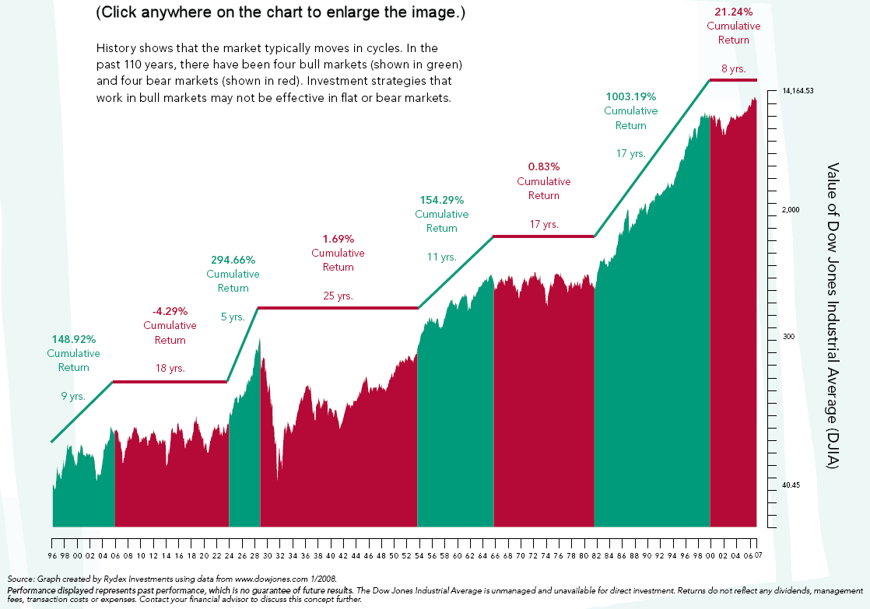

16. Based on the diagram, write a brief definition for EITHER “bull market” or “bear market.”

17. During what years did the Dow-Jones give its best returns?

18. During what years did the Dow-Jones decline most steeply?

19. According to the chart, what was the value of the Dow Jones in 2007? Hint: its value was 17,778.15 as of yesterday.

20. Between 1896 and 2007, how many TOTAL YEARS was the DJIA in a bull market?

**Secondary Sources:** the excerpt below is from popular historian Laura Hillenbrand’s book *Seabiscuit: An American Legend*. It describes Red Pollard’s leg injury just prior to Seabiscuit’s race with War Admiral. Read it carefully, and then compare it to the film we saw. Evaluate which source seems more accurate, then explain which one better helps you understand American life during the late Depression. Support your judgement using at least three specific examples from either (or both) of the two sources. 15 points.

Reminders: Red Pollard is Seabiscuit’s regular jockey. Tom Smith is Seabiscuit’s trainer. Winthrop Hospital is on Pleasant Street, and the accident happened at Suffolk Downs. I’m guessing that the “road running perpendicular to a river” is the road that connects the Suffolk Downs T station to East Boston through the marsh. “Hotter than a smoking .45” is a reference to a gun that has just been fired.