Winthrop High School
English Department Writing Guide
Version 3.0

Table of Contents

Literary Analysis Essay Guidelines………………………….2
Thesis Essay Structure……………………………………….3
Thesis Statement and Topic Sentence Structures…………....4
Body Paragraph Structure…………………………………....7
Advanced Literary Analysis Thesis Structures………………8
Position Statements…………………………………………..9
Transitions…………………………………………………..10
Incorporating Quotations…………………………………....11
MLA Citation………………………………………………..13
Sample MLA Format………………………………………..15
Tone…………………………………………………………16
Style…………………………………………………………17
Theme……………………………………………………….18

Literary Analysis Essay Guidelines

Students SHOULD:
- write in present tense
  - ex. Romeo desires Juliet.
- assume the reader has read the text
  - no summaries about the story, characters, or setting
- assume the reader has a full understanding of literary terms
  - ex. do not define “symbolism”, just analyze the symbol
- focus on the meaning of the text, not an emotional response
  - refrain from judging the text based on personal/emotional reactions and stick to an analysis of the meaning and concrete evidence
- use direct evidence (quotes) from the text to support claims
- use MLA format for all formal essays, including in-text citations and works cited pages

Students SHOULD NOT:
- restate the prompt verbatim
  - the reader is familiar with the prompt, so always refrain from telling the reader what he or she knows
  - however, students should learn how to integrate language from the prompt into their introductory paragraphs
- use 1st or 2nd person voice
  - no “I”, “me”, or “you”
- praise or criticize the writer
  - students are not in the position to formally judge the merits of a writer’s ability, but should focus on a specific text. In other word, avoid “Shakespeare’s talent is evident because…” or “Orwell’s writing lacks depth because…”
- use words they do not understand
  - avoid using impressive sounding words that do not work in the context of the sentence
- use clichés or redundant phrases, especially for transitions
  - avoid empty phrases like “To begin”, “To conclude”, “All in all”, “As stated before”, “In closing”, etc.

Paragraph 1

Introduction
Purpose: To introduce the topic and clearly state the thesis

Paragraphs 2,3,4

Body paragraphs
Topic sentence (point 1)
Quotes/Evidence from Text
Analysis of evidence
Transition
Purpose: To support your thesis by presenting 3 points (remember those three points from thesis) and textual evidence for each point
Topic sentence (point 2)
Quotes/Evidence from Text
Analysis of evidence
Transition
Topic sentence (point 3)
Quotes/Evidence from Text
Analysis of evidence
NO TRANSITION

Paragraph 5

Conclusion
Purpose: To reiterate argument and remind readers why this essay was relevant to them

Thesis Essay Structure

Introduction

Body Paragraphs (3)

Conclusion

Introduction
1. HOOK: General statement that is compelling, interesting, and related to the topic
2. SUMMARY SENTENCE(S): Author’s name, title of work, and a brief, relevant summary of the work
3. THESIS: Presents the argument you will prove throughout the essay – often includes three points you’ll make to prove your thesis

Body Paragraphs
1. TOPIC SENTENCE: Supports your thesis and states what your paragraph is about (based on points at end of your thesis)
2. QUOTES: Textual evidence for the point you’re making
3. LINK quotes to theme: Analyzes exactly how quote is evidence that your point about the theme is valid.
4. TRANSITION: Sums up/mentions your point and connects it to the next one

Conclusion
1. RESTATE thesis in different words.
2. SUMMARIZE, in different words, the point made in each paragraph.
3. GO BEYOND: Answer the question, “In what way was this topic relevant to everyone?” aka “So what?”

Thesis Statement and Topic Sentence Structures

Definition Style Thesis
** To be used during the 1st semester of freshmen year and for struggling writers

To define or make a conclusion about an element of the text and provide evidence to support this definition or conclusion

(X) is (Y) because of (A), (B), and (C)

Example Prompt: Analyze why Hamlet is a tragic hero in the play Hamlet.

Ex. Hamlet is a tragic figure because of his inability to take action, obsession with avenging his father’s murder, and fragile state of mind.

Topic Sentence Structure:

1) topic = direction from thesis statement (A), (B) or (C)
2) claim = one verb
3) universal idea = must link to thesis to achieve unity
4) direction = contextual evidence of topic, examples not quotes

Example:
Topic Sentence #1:
Hamlet’s inability to take action against Claudius heightens his mental anguish and leads to his tragic downfall.

Topic Sentence #2:
Hamlet’s obsession with avenging his father’s murder causes him to behave irrationally and tragically spurs him to alienate his loved ones.

Topic Sentence #3:
Hamlet’s fragile state of mind spurs him to contemplate suicide and eventually leads to his untimely, tragic death.

BASIC Literary Analysis Thesis

To convey (1) the meaning of the work and (2) how the author conveys that meaning with literary devices. Particularly useful for poetry, prose excerpts, and short fiction.

Components:
1) topic = name of the text
2) claim = one verb
3) universal idea = theme
4) direction = literary devices used to convey theme (USE AT LEAST TWO)

In (title of text), (author) uses (literary device #1), (literary device #2), and (literary device #3) to prove (universal idea).

Ex. In the poem “The Road Not Taken”, Frost uses natural imagery, an extended metaphor, and first person point of view, to prove that self-reliance is an often difficult, but vital, choice.

Open-Ended Prompt Response Thesis:

For open-ended prompts that focus on a particular thematic aspect of the text.

Same as Type #1 structure except the direction (literary devices) are replaced by concepts/general examples from the text that must show how the universal idea functions. The topic is switched from the title of the text to the thematic focus of the prompt.

Prompt Example (AP 2010 Form B Question #3)
“You can leave home all you want, but home will never leave you.” —Sonsyrea Tate
Sonsyrea Tate’s statement suggests that “home” may be conceived of as a dwelling, a place, or a state of mind. It
may have positive or negative associations, but in either case, it may have a considerable influence on an individual. Choose a novel or play in which a central character leaves home yet finds that home remains significant. Write a well-developed essay in which you analyze the importance of “home” to this character and the reasons for its continuing influence. Explain how the character’s idea of home illuminates the larger meaning of the work. Do not merely summarize the plot.

Ex. Thesis: Home is important to Nick Caraway because it provides comfort, foundational identity, and a point of reference, establishing the fact that one can’t escape the past.

Topic Sentence Structure

1) topic = direction #1 from the thesis statement (lit device or concept)
2) claim = one verb
3) universal idea = from thesis, must have unity
4) direction = contextual evidence of topic, examples not quotes

BASIC Literary Analysis Thesis Statement:

In the novel The Street, Petry uses probing diction and malevolent personification to expose the alienation that results from society’s inability to protect the individual from nature’s violent assault.

Topic Sentence #1:

Probing diction generates a deep sense of isolation when the wind explores Lutie and obscures her vision.

Topic Sentence #2:

Malevolent personification of the wind conveys the absurdity of Lutie’s interaction with the urban environment when the author depicts the wind’s dominance over the pedestrians and Lutie in particular.

AP Prompt 1980 #3: A recurring theme in literature is the classic war between a passion and responsibility. For instance, a personal cause, a love, a desire for revenge, a determination to redress a wrong, or some other emotion or drive may conflict with moral duty. Choose a literary work in which a character confronts the demands of a private passion that conflicts with his or her responsibilities. In a well-written essay show clearly the nature of the conflict, its effects upon the character, and its significance to the work.

Open-ended Prompt Response Thesis:
Proctor’s passion for his family conflicts with his sense of moral duty, shown through his struggle to reveal the truth and his decision to sacrifice his life, revealing that confronting injustice often involves great personal turmoil.

Topic Sentence #1:

Proctor’s struggle to reveal the truth, which involves his confession of adultery and accusations against Abigail, proves that confronting injustice often involves great personal turmoil.

Topic Sentence #2:

Proctor’s decision to sacrifice his life, motivated by a desire to expose the court’s hypocrisy and his refusal to tarnish his name, proves that confronting injustice often involves great personal turmoil

Body Paragraph Structure

* Topic Sentence then:
1) Identify = state 1st direction from topic sentence (ex. when the wind explores Lutie)
2) Evidence = provide quotes to illustrate the direction
3) Link = connect direction to the universal idea through analytical commentary – THIS SHOULD BE THE BIGGEST PART OF THE BODY PARAGRAPH!

Example body paragraph structure:

*Topic Sentence #1 = direction #1 from thesis statement, verb, universal idea from thesis, direction #1+2 (contextual evidence of topic)
I. Identify Direction #1 from topic sentence #1
II. Provide evidence (quotes) for Direction #1
III. Link Direction #1 to the thesis statement’s universal idea through commentary/analysis
IV. Identify Direction #2 from topic sentence #1
V. Provide evidence (quotes) for Direction #2
VI. Link Direction #2 to the thesis statement’s universal idea through commentary/analysis

Example:

Probing diction generates a deep sense of isolation when the wind explores Lutie and obscures her vision. For example, when the wind explores her Petry writes that Lutie “felt suddenly naked and bald” and “shivered as the cold fingers of the wind touched the back of her neck”. Words like “naked”, “bald”, and “shivered” heighten Lutie’s sense of isolation and vulnerability to her environment because it is as if she is being violated and nobody comes to her aid. They also serve to reinforce the wind’s ability to expose Lutie’s self to the merciless urban streets and her helplessness in response. Futhermore, when the wind obscures her vision, it “push[es]” and “twist[s]” the sign away from her and finally “swoop[s]” it away until it is at “an impossible angle”. The use of the verbs “push”, “twist”, and “swoop” all connote aggression reinforcing the wind’s assault on her body and reason. This results in Lutie’s paralyzing inability to interact with her environment, as least momentarily, heightening the wind’s control over her fate.
ADVANCED Literary Analysis Thesis Structure:

Tone Shift Structure:

In (title of work), the author shifts from a (TONE 1) tone to a (TONE 2) tone by using (adj. + device #1), (adj. + device #2), and (adj. + device #3), proving that (UNIVERSAL IDEA).

Contrast Structure:

In (title of work), the author contrasts (concept #1) with (concept #2) by using (adj. + device #1), (adj. + device #2), and (adj. + device #3), proving that (UNIVERSAL IDEA).

- qualify direction with adjectives
- switch out qualifying verb “proving” with one that more closely mirrors what is happening in the text
- incorporate a short phrase from the text in the universal idea

Examples:

Thesis: In “The Birthday Party”, Brush shifts from a mundane tone to an uncomfortable tone by using colloquial language, varied syntax, and shifting points of view, revealing that assumptions “burning at the center” of individuals are often deceptive.

Thesis: In Gary Soto’s essay, he shifts from a glutinous tone to one of remorse by using biblical allusions, sensuous imagery, and emotionally-charged symbolism to demonstrate that “sin is what you [take] and [don’t] give back”.

Thesis: In the excerpt from Kiss and Tell, de Botton contrasts the mother and daughter’s personalities by using situational irony and humorously inappropriate dialogue to expose the hypocrisy of judgmental family members that “dwell in ignorance” of their own quirks.

Thesis: In “The Century Quilt”, Waniek shifts from a reflective to speculative tone using comforting imagery and chronological structure to illuminate that one’s “quilt” of experience weaves together “childhood…miracles” and dreams of the “as yet unconceived”.

Topic S. #1: Comforting imagery culminates in the interweaving of time and experience as the speaker depicts objects and family in her past, present, and future.

Topic S. #2: The cyclical and chronological structure creates an intertwining of memory and dream through the speaker’s childhood memories and musings on the future.

Thesis: In We Were the Mulvaneys, Oates shifts Jud Mulvaney’s perspective from unsettled reflection to dreadful realization through the use of epiphany, indirect characterization, and obsessive repetition accentuating the fact that “living things are dying, dying, dying all the time”.

Topic S. #1: Epiphany evokes Jud’s realization of death’s universality as his awareness grows from the personal to the communal.

Topic S. #2: Obsessive repetition further signals Jud’s fixation on inevitable mortality when he generalizes his stark observation about his ephemeral heartbeat.

Topic S. #3: Indirect characterization develops Jud’s internal struggle with life’s impermanence through his observations and reflections on his environment.
Position Statements

A position statement is like a thesis or goal. It describes one side of an arguable viewpoint.

Topic: | School uniforms
Arguable  Viewpoints: | For/against school uniforms  For/against a stricter dress code

To write a position statement, gather a list of reasons to support a particular viewpoint.

Viewpoint: | For school uniforms
Supporting  Reasons: | Ensure equality  Save money  Help students identify visitors

Viewpoint: | Against school uniforms
Supporting  Reasons: | Eliminate free expression  Cause teachers to waste time  Are too expensive to buy and maintain

Next, write a sentence or two that pulls all the information together and makes your stand clear to the audience.

Position Statement EXAMPLES:

Pro School Uniforms | A uniform policy will ensure true equality in schools, save families money, and help schools identify visitors easily.
Anti School Uniforms | Uniforms would cause more problems in a school than they would solve. They eliminate free expression, cause teachers to waste time, and are too expensive.

Transitions

A transition between paragraphs can be a word or two (however, for example, similarly), a phrase, or a sentence. Transitions can be at the end of the first paragraph, at the beginning of the second paragraph, or in both places.

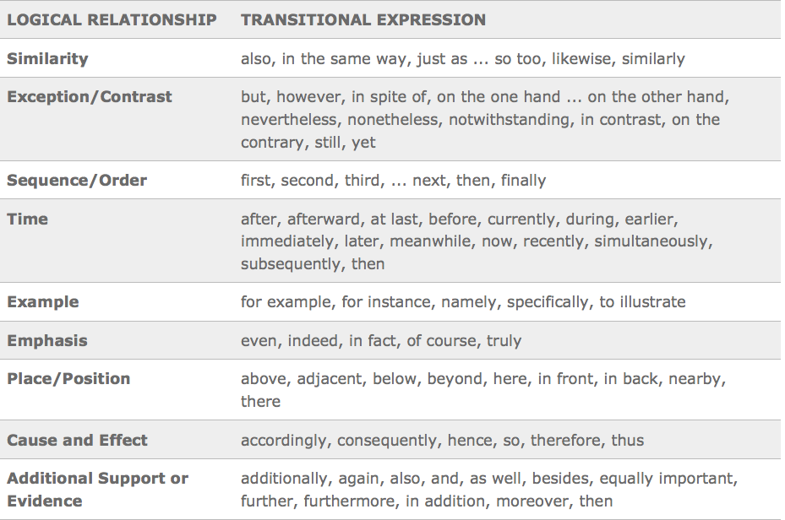
source: The Writing Center, University of North Carolina at Chapel Hill

Incorporating Quotes Into Your Paper

In your writing, you should use quotations for one or more of the following specific purposes:

- Use quotation to reproduce distinctive or unique wording- that is, when a paraphrase would be an inadequate representation.
- Use quotation when your source uses word in a specialized or unorthodox way.
- Use quotation when the speaker or writer is an expert on the subject or an otherwise famous person whose specific words might be newsworthy, or general interest, or add credibility to your paper.
- Use quotation to reproduce important statements of information, opinion, or policy.
- Use quotation to reproduce exactly a passage that you are explaining or interpreting.

The ultimate test of whether a quotation is necessary or not is this: Does it help support your thesis?

Always introduce your quotes. Any quote that lacks an introduction is called a
floating quote. Never use floating quotes in your paper! They are confusing and
disorienting. Furthermore, do not simply rephrase a quote. Look behind the words and answer the question, “What ideas or meanings do these words convey?” This is where your close reading skills come in! Analyze each quotation. Quotations are not self-evident! Prove how the quotation supports the universal idea/theme in your thesis statement.

After each quote, include an in-text citation (parenthetical reference).

Quotation Tips

- Use in-text citations to cite quoted material: (Rowling 52).
  - When you do not know the author of a text, such as an article from the internet, use the first word of the title for your in-text citation: (Afghanistan).
- If you state the author’s name or the title of the work in your sentence, do not include it in
- the parenthetical note: (52).
- Ellipses (…) appear within and at the end of a quote if you have omitted any words. Do
- not place ellipses at the beginning of a quote.
- Use brackets [ ] to indicate any changes or additions you have made in the quote.
- Always italicize titles of novels, plays, and films.
- Provide a “Works Cited” page at the end.

In-text Citations

Example A
“But if there were hardships to be borne, they were partly offset by the fact that life nowadays had a greater dignity than it had had before” (Orwell 117).

By putting the author's last name, Orwell, and the page number, 117, in parentheses after your quotation, you are telling the reader where you found this information. The quote should be within quotation marks. The citation comes after the quotation but before the period.

Example B
Orwell states, "if there were hardships to be borne, they were partly offset by the fact that life nowadays had a greater dignity than it had had before” (117).

Because you have mentioned the author's name in your sentence, you do not have to repeat it in the parentheses.

Example C
Orwell states that although times were tough, the effects were softened by the fact that there was a “greater dignity” in life than there was before (117).

Sentences in your own words about the idea(s) of an author are treated in much the same way. Here there is only one set of quotation marks around the words that were specialized in the text.

Example D
As he walks the exhibitions at the “Great Exposition” of 1900, Adams marvels at the dynamo gallery with its forty-foot machine and he catalogues the tremendous effect it has on his sense of things:
The planet itself seemed less impressive, in its old fashioned, deliberate, annual or
daily revolution, than this huge wheel, revolving within arm’s-length at some
vertiginous speed, and barely murmuring—scarcely humming an audible warning
to stand a hair’s-breadth further for respect of power—while it would not wake a
baby lying close against its frame. Before the end, one began to pray to it;
inherited instinct taught the natural expression of man before silent and infinite
force. (318)

Quotations that are 5 or more lines long do not need quotation marks. Instead the quotation is indented. The citation follows the period at the end of the quote.
Formatting MLA (7th ed.) Works Cited Pages:

** Teachers will take all freshmen English classes to the library for a workshop on MLA citation during the first semester.

The Works Cited page provides all the publication information a reader would need to locate each of the sources in your paper. The words, Works Cited, should be centered at the top of the page. Arrange the citations in alphabetical order by the first element of the citation (excluding “a,” “an,” or “the”). The first line of the entry is not indented, but any additional lines pertaining to the same entry are indented one-half inch.

As with every other part of an MLA formatted essay, the proper font is 12 pt. Times New Roman, and the bibliography is double spaced, both within the citation and between citations. Do not add an extra line between the citations.

Titles of books, web sites, magazines, and newspapers should be italicized. Titles of articles in magazines, newspapers, and web sites, stories within an anthology, poems, and songs should be in quotation marks.

How to cite commonly used sources:
Book:
Last name of author, First name. Title of Book. City: Publisher, Year. Print.
Book with an editor (no single author):
Last name of editor, First name, ed. Title of Book. City: Publisher, Year. Print.
Work in an Anthology or Collection:
Last name of author, First name. “Title of Story.” Title of Anthology. Ed. Editor’s name(s). City:
Publisher, Year. Page(s). Print.

Web source (Web sites):
Last name of author, First name. “Title of Article.” Title of Entire Website. Name of
institution/organization affiliated with the site (sponsor or publisher), Day Month Year
of publication. Web. Day Month Year of access. <URL>.
To cite a database article, click the icon, “Citation tools” to learn how to cite the article in MLA.

*To learn how to cite more sources (pictures, movies, etc.), go to http://owl.english.purdue.edu and click on MLA 2009 Formatting and Style Guide. The web sites, www.bibme.org or www.easybib.com, can also help you create bibliographies. There is a tutorial on the WHS Library Web site that you can watch to learn how to use easybib.com.
Works Cited Page Example:

Works Cited
"Afghanistan: Lessons from the Last War." The George Washington University. U.S. Army, 9 October 2001. Web. 15 Sept. 2011. <http://www.gwu.edu/~nsarchiv/NSAEBB/NSAEBB57/us.html>.
Burciaga, Jose A. “La Puerta.” Adventures in Reading. Ed. Fannie Safier. New York: Holt, Rinehart, and Winston, Inc., 1996. 166-70. Print.
Hosseini, Khaled. A Thousand Splendid Suns. New York: Riverhead Books, 2007. Print.
"Jack London." Merriam Webster's Biographical Dictionary. Springfield, MA: Merriam-
Webster, 1995. Gale Biography In Context. Web. 7 Dec. 2011. <http://ic.galegroup.com>.
Klein, Misha. "Background.” September 11: Context and Consequences. an Anthology. Ed.
Adrian L. McIntyre. Berkeley, CA: Copycentral, 2001. 120-30. Print.
Miller, Raymond H. The War in Afghanistan. Farmington Hills, MI: Lucent Books, 2003. Print.

Sample MLA Format
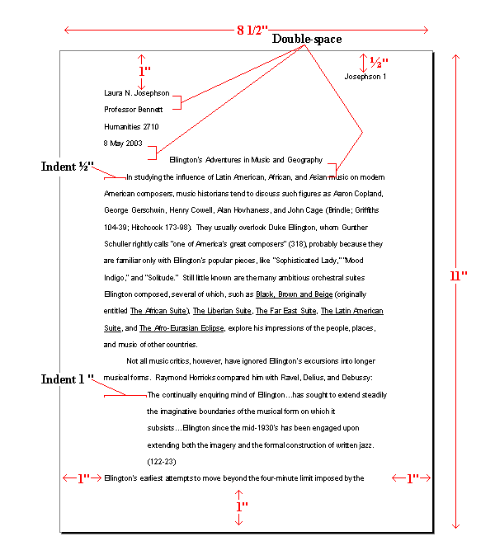

Tone

Tone: the author’s implied attitude in a work of literature. Tone and mood are not interchangeable. The tone of a story is often defined as what the author is feeling towards the subject, rather than what the reader feels. What the reader feels is defined as the mood.

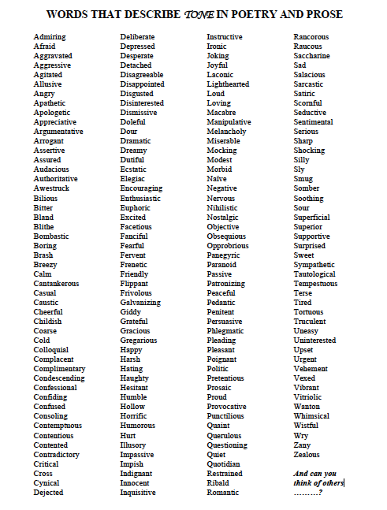
Style

Style is, in addition to meaning, an outcome of an author’s manipulation of all literary techniques, not just diction. Style encompasses the author's words and the characteristic way that writer uses language to achieve certain effects. An important part of interpreting and understanding fiction is being attentive to the way the author uses words. What effects, for instance, do word choice and sentence structure have on a story and its meaning? How does the author use imagery, figurative devices, repetition, or allusion? In what ways does the style seem appropriate or discordant with the work's subject and theme? Some common styles might be labeled ornate, plain, emotive, or scientific. Most writers have their own particular styles, thus we speak of the "Hemingway style" or "Dickensian style."

Language: Different from tone, 'language' describes the force or quality of the diction, images, details, etc.
Terms to Describe Language

Archaic (old, antiquated)  Artificial  Bombastic (overblown, pompous, inflated)  Concrete  Colloquial (conversational)  Connotative (suggestive)  Cultured  Deflated (reduced in importance)  Detached  Emotional  Esoteric (understood by or meant for only the select few who have special knowledge or interest)  Euphemistic (inoffensive, agreeable)  Exact  Fantastic (flights of fancy)  Figurative  Formal  Grotesque (bizarre, incongruous)  Homespun (simple, homely)  Idiomatic (dialect)  Informal  Insipid (dull, flat)  Jargon (technical vocab of a particular group) | Learned  Literal  Lyrical (expressing intense emotion)  Metaphorical  Moralistic  Mundane (commonplace)  Obscure  Obtuse (not clear/precise)  Ordinary  Pedantic (ostentatiously learned)  Picturesque (quaint, charming)  Plain  Poetic  Pompous  Precise  Pretentious (showy)  Provincial (narrow, unsophisticated)  Scholarly  Sensuous (appealing to the senses)  Simple  Slangy  Trite  Vulgar

Theme

Theme is the underlying message of a literary work. It should not be confused with topic, which is a subject of the work. Theme is the author’s commentary on a topic, conveyed through the characters, plot, tone, and stylistic choices. A literary work’s theme is always related to the human condition. In other words, it is the author’s commentary on some universal aspect related to what it means to be a human being. Literary works usually contain multiple topics and themes. Theme may also be referred to as a work’s universal idea.

Examples:

A topic in William Shakespeare’s play Macbeth is ambition.

However, the theme of this topic is that unchecked ambition leads to destruction.

This is Shakespeare’s message about the topic of ambition. The reader determines this theme by analyzing the characters’ motivations and actions, the plot of the play, Shakespeare’s tone, and the language that Shakespeare uses to portray these elements.

A topic in William Golding’s novel The Lord of the Flies is the loss of innocence.

However, the theme of this topic is that crisis situations often require people to make difficult decisions that may compromise their ideals, resulting in a loss of innocence.

This is Golding’s message about the topic of the loss of innocence. The reader determines this theme by analyzing the characters’ motivations and actions, the plot of the novel, Golding’s tone, and the language that Golding uses to portray these elements.

A topic in Robert Frost’s poem The Road Not Taken is self-reliance.

However, the theme of this topic is that although it may be difficult to diverge from the crowd, one must think independently.

This is Frost’s message about the topic of self-reliance. The reader determines this theme by analyzing the speaker’s motivations and actions, the speaker’s tone, as well as the language Frost uses in the poem.

