15' Gokstad Replica
For the second phase of our project we have decided to step up to the challenge of building a larger model. The choice was a 15 foot replica of the Gokstad ship. The authentic 76-foot vessel was excavated on the Gokstad estate in Vestfold, Norway in 1880. The students' only experience with boat building was 36-inch model of a ship that came with directions!
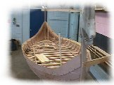
The students in the project began to gather the necessary information and materials needed to complete this model. The students and advisors gathered a very impressive library of books and Internet sites on Vikings and their culture. From the information gathered, they began to loft the lines for the Gokstad. Unfortunately, lack of funding forced us to use basswood, Luan plywood, and some oak, Instead of pine, ash, and oak. This would prove a terrible impediment. It was much more difficult to work with these materials.
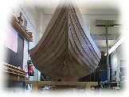
We believe the proper woods would have been much easier to work with, stronger, and more forgiving. However, with each problem the students' resolve, they become stronger. The former tech-ed class and the academic classes worked over time to gather every piece of information to help create a successful model. We have now adding the finishing touches to our replica. It had been placed in the front foyer of Winthrop High School as the first major exhibit in our planned museum but can now be found in the V.L.P room
