September 13, 2013
Hello,
We had a great first week of preschool! This week we talked about beginning preschool and making friends. We read some great books! They are D.W.’s Guide to Preschool by Marc Brown, The Kissing Hand by Audrey Penn, Making Friends by Ellen Crimi-Trent and Llama Llama and the Bully Goat by Anna Dewdney.
Our friends, Ms. Rose and Ms. Janis, both occupational therapist, come in everyday to work with us and help us make some fun crafts and do fun activities. Ms. Rose comes Tuesday through Thursday and Ms. Janis comes on Friday. Some of these crafts have been sent home and some we keep here at school.
I look forward to a great year and have really enjoyed our first week!
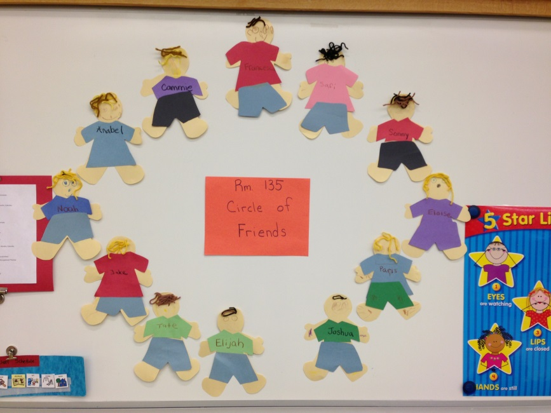
Love,
Ms. Jen

