March 7, 2014
Hello Families,
We spent the past two weeks reading and learning about Dr. Seuss. We read many of his great stories and talked about all the rhyming words found in the stories. The children really enjoyed playing with rhyming words and telling me when they heard these words.
Some of the stories we read were The Cat in the Hat, Oh, The Places You’ll Go!, Wings on Things, Bartholomew and the Oobleck, One Fish Two Fish Red Fish Blue Fish and many, many more! After reading these stories we did some fun activities. We made oobleck, hot air balloons, Dr. Seuss hats, etc! Oh, what fun we had!! Check out my School Fusion Page to see the pictures of the children in their hats!
During the past two weeks, we learned the letters “o” (for oobleck) and “s” (for Dr. Seuss)! The children are doing great with their letters, keep up the great work practicing with them!!
Have a great weekend!
Ms. Jen
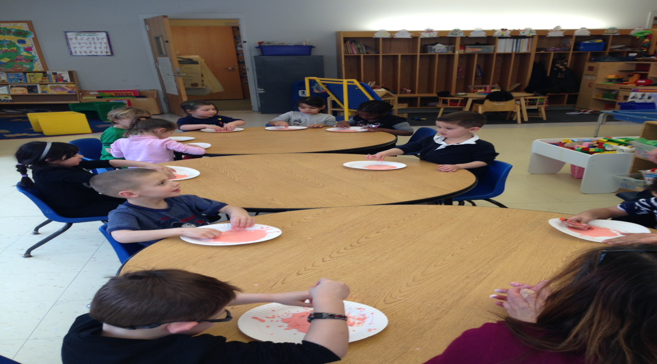 (“O” for Oobleck)

