Beowulf Unit Objectives and Literary Terms

Epic Poetry: “Beowulf”

- To analyze Old English, its structure and sound patterns.
- To identify elements of Anglo-Saxon culture that is reflected in Beowulf.
- To identify the characteristic of epic poetry and the oral tradition of folk literature.
- To analyze the use of imagery and symbolism in the poem.
- To analyze the central theme of the poem.
- To analyze the characteristics of the Anglo-Saxon hero and antagonist and how they relate to the central characters.
- To demonstrate an understanding of narrative writing by establishing conflict and plot.
- To analyze the use of allusion, kennings, irony and foreshadowing in the poem.

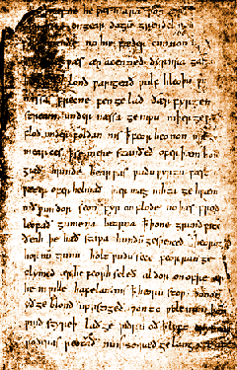

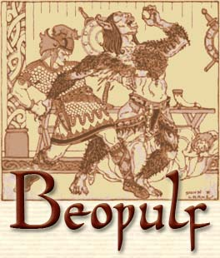

Define the following literary terms as you use them throughout the analysis of the text.

Epic
Epic Hero
Simile
Metaphor
Personification
Imagery
Allusion
Theme
Characterization
Symbol
Kenning
Irony
Foreshadowing
Antagonist
Conflict
Plot
Folk Literature
Alliteration

